Git Branching and Merging Exercise Report (4. Git-HOL)
This document contains the screenshots captured while performing the Git branching and merge conflict exercise.

Screenshot 1 – Merge Conflict
Merge conflict generated after executing git merge GitWork.
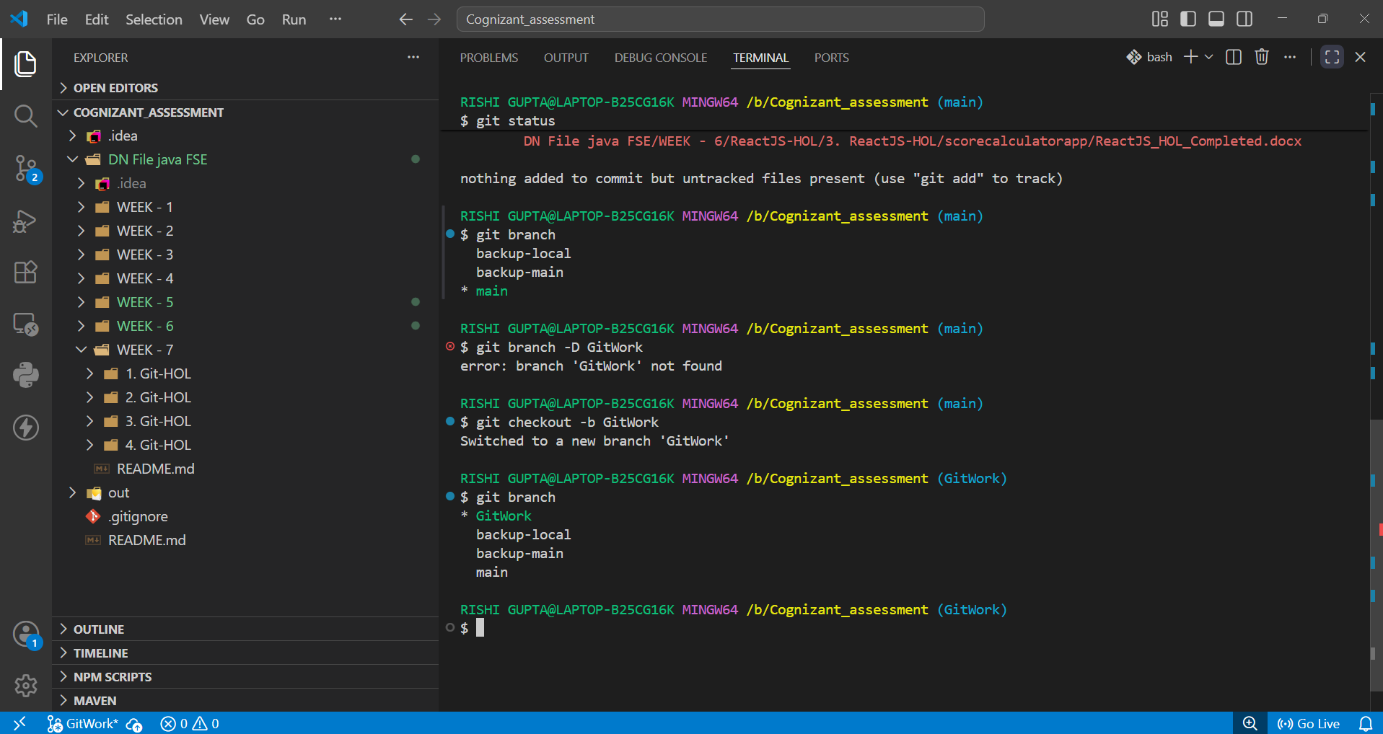

Screenshot 2 – Conflict Resolved
Conflict resolved, file staged, merge commit created successfully.
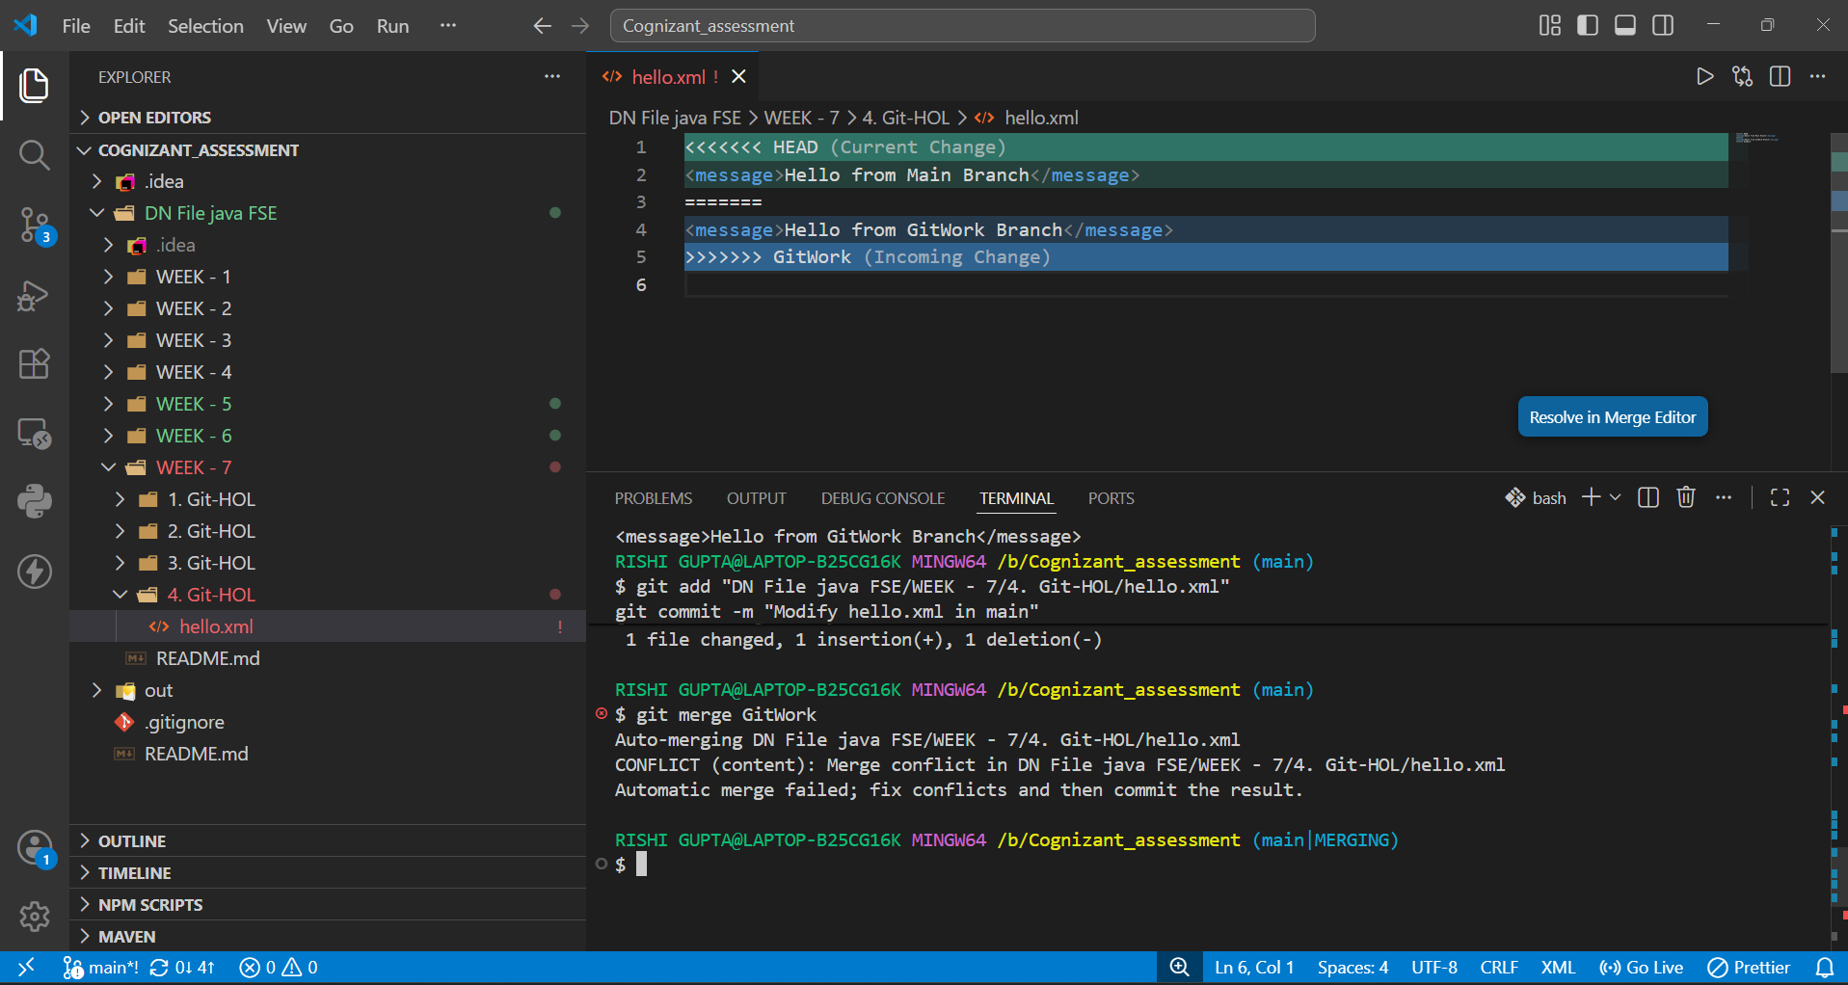

Screenshot 3 – Final Commit Graph
Final commit graph confirming successful merge.
